**Fop Lab Task 6**

**Name:** Hafiz Mufassir Amjad

**CMS ID:** 456049

**Section:** B

**TASK 1**

#include <iostream>

using namespace std;

int main()

{

int sum = 0, length;

int num1 = 0, num2 = 1;

cout<<"Enter length of the sequence: ";

cin>>length;

sum = num1 + num2;

cout<<num1<<", "<<num2<<", "<<sum<<", ";

for (int i = 0; i<length-3; i++) {

num1 = num2;

num2 = sum;

sum = num1 + num2;

for (int j = 0; j<1; j++) {

cout<<sum<<", ";

}

}

}

**Output**

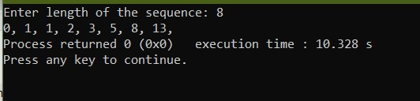

**TASK 2**

#include <iostream>

using namespace std;

int main()

{

int rows, num = 0;

cout<<"Enter the number of rows: ";

cin>>rows;

for (int i = 1; i<=rows; i++) {

for (int j = 1; j<=i; j++) {

cout<<" "<<++num;

}

cout<<endl;

}

}**Output**

